
Bensalem Residents are invited to attend
CHILD IDENTIFICATION SAFETY DAY

Sunday, April 6, 2014
12:00 PM - 3:00 PM
Bensalem Township Municipal Building
2400 Byberry Road
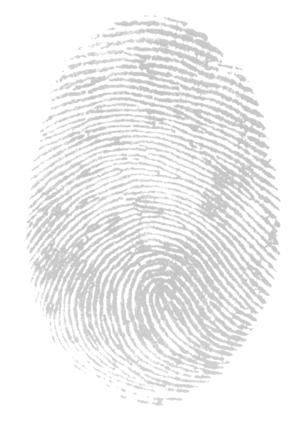
Mayor Joseph DiGirolamo, along with Township Council, will be hosting a Child Identification Safety Day. Bensalem Township will be partnering with forensic DNA laboratory, Bode Technology. The child’s DNA will be collected in a non-invasive, child friendly manner, sent to Bode Technology for processing and returned directly to the parent….FREE OF CHARGE

Door prizes


Light refreshments

Bensalem Police K-9

Bensalem Police Motor Patrol


Eddington Fire Company

The township is encouraging parents to take advantage of the opportunity to obtain your child’s forensic DNA profile, free of charge, in case it is ever needed. At no time will Bode Technology or the Bensalem Police retain a copy of the profile.

If you have any questions regarding this event, please feel free to contact the Office of the Director of Public Safety at 215-633-3711. We look forward to seeing you.

“Partnering to keep our community and children safe”




